

# DLO Musical Theatre Audition Form

# PLEASE PRINT CLEARLY

**NAME**: _______________________________________________________________________________________

**FULL ADDRESS**: _______________________________________________________________________________________

**PHONE NUMBER**: _________________________________ **Do you receive text messages at this number?** [ ] Yes [ ] No

**EMAIL ADDRESS**: ___________________________________________

**AGE** (if under 18): **Name(s) of Parent(s)/Guardian(s)**:

**• Contact info for Parent(s)/Guardian (if different from above)**: _ ____

___________

**• Role(s) for which you are auditioning**: _______________________________________________________________

**• If not cast in the role(s) listed above, are you willing to accept another part**? [ ] Yes [ ] No

**• Callbacks** will be held on Saturday, October 20, 2:00 p.m. – 5:00 p.m. Please indicate any conflicts you have during this time:

__________________________________________________________________________________________________________

**• MUSICAL THEATRE EXPERIENCE**: If you have a theatre resume, please attach to this sheet. If not, please use the form on the  
 reverse side of this sheet. Thank you!

**• DANCE EXPERIENCE:** ____________________________________________________________________________________

**• OTHER RELEVANT EXPERIENCE**: _____________________________________________________________________________

**• Do you play a musical instrument**? [ ] No [ ] Yes -- Instrument(s): _________________

**• VOCAL RANGE** (may be completed by music director):

**[ ] Soprano [ ] Mezzo-soprano [ ] Alto [ ] Tenor [ ] Baritone [ ] Bass**

• To assist with rehearsal planning, **on a scale of 0 (none) to 5 (expert) how skilled**

**are you at reading music** (i.e. accurately teaching yourself notes and rhythms if

given access to a piano and some time to work on it)?

**[ ] 0 [ ] 1 [ ] 2 [ ] 3 [ ] 4 [ ] 5**

|  |
| --- |
| **IMPORTANT: By completing and turning in this form, you confirm that you have read and understand the information below.** |

**REHEARSAL SCHEDULE CONFLICTS: *Performers are expected to be at every scheduled rehearsal unless prior arrangements have been made with the director.*** Failure to attend rehearsals may result in dismissal from the show. Rehearsals for Next to Normal will be scheduled **after casting**. We anticipate once weekly rehearsals through the holidays, once or twice weekly January through mid-March, and then three times a week until tech week. Rehearsals, depending upon availability, will be scheduled for 6:30-9:30 p.m. on weekdays, and/or sometime between 12:00-9:30 p.m. on weekends. During tech week, there will be rehearsal every night.**On the calendar provided, please mark all known dates when you will be UNAVAILABLE.**

|  |
| --- |
| ALL cast members are expected to assist with move-in on Saturday, April 20, and Sunday, April 21.  ALL cast members are expected to assist with strike on Sunday, April 28. Since this is a small cast, please think about  recruiting extra help for the strike. We would appreciate it. A lot! |

**Participation fee: [ ] Adult $25 [ ] Student $10**  (DLO's non-refundable participation fee IS waived for DLO Season Subscribers.

**EVERY cast member issued script/music materials must pay a $25 security deposit on each book, which will be refunded** when the items are returned on time and in good condition.

Please indicate your interest in volunteering with any of the following backstage opportunities:

|  |  |  |  |  |  |  |
| --- | --- | --- | --- | --- | --- | --- |
| **[ ] costumes** | **[ ] set** | **[ ] lights** | **[ ] sound** | **[ ] stage crew** | **[ ] props** | **[ ] makeup** |

**Theatre Resume for Next to Normal Auditions**

NAME: __________________________________________________________________

**Please list your theatre experience starting with most recent and going backward.**

**PERFORMANCE** EXPERIENCE (If more extensive, please just list up to last 10 shows.)

|  |  |  |  |
| --- | --- | --- | --- |
| Month/Year | Show | Role | Theatre Company |
|  |  |  |  |
|  |  |  |  |
|  |  |  |  |
|  |  |  |  |
|  |  |  |  |
|  |  |  |  |
|  |  |  |  |
|  |  |  |  |
|  |  |  |  |
|  |  |  |  |

**NON-PERFORMANCE** EXPERIENCE (direct, produce, sound, lights, set, etc. – if extensive, please just list up to last 10 shows.)

|  |  |  |  |
| --- | --- | --- | --- |
| Month/Year | Show | Position | Theatre Company |
|  |  |  |  |
|  |  |  |  |
|  |  |  |  |
|  |  |  |  |
|  |  |  |  |
|  |  |  |  |
|  |  |  |  |
|  |  |  |  |
|  |  |  |  |
|  |  |  |  |

**ADDITIONAL NOTES if needed:**

**NAME: _________________________________________________________**

**Please put an X on days you are completely unavailable. For partial day conflicts, note hours that you are NOT available. (Yes, we understand that things come up, but the more information we have now, the better for you and for the show!)**

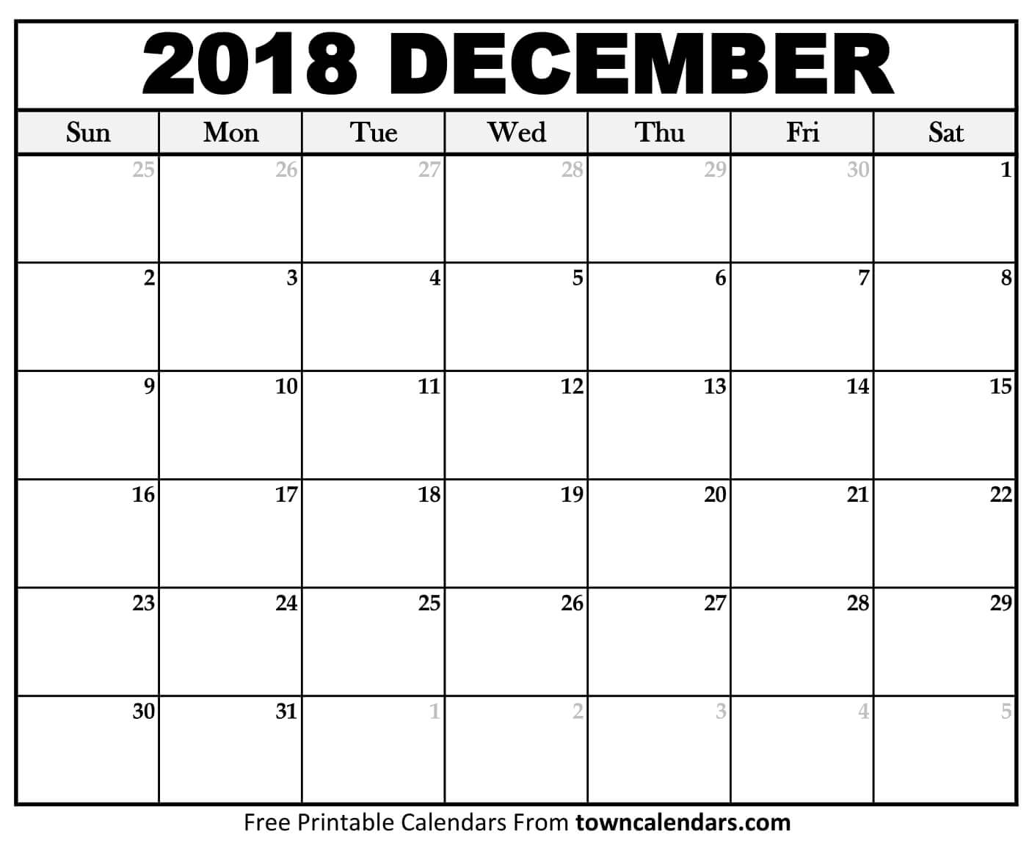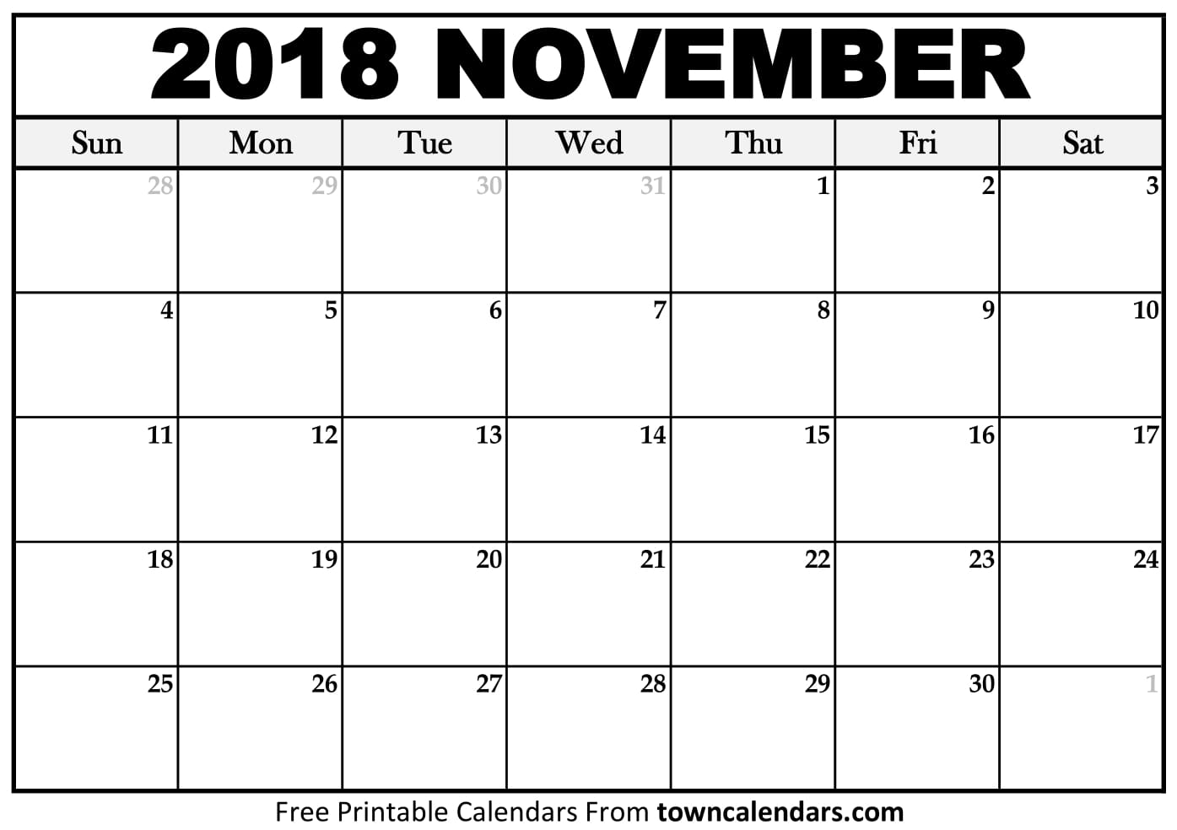

****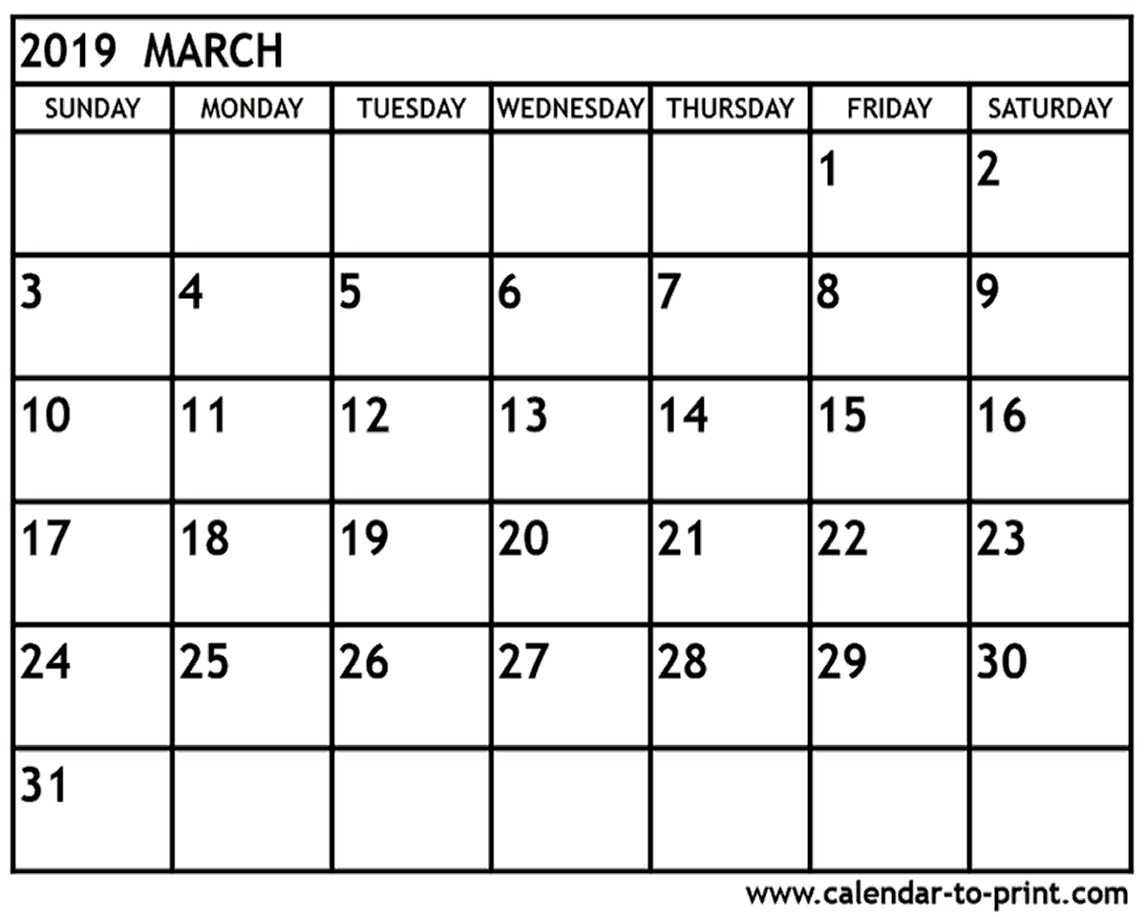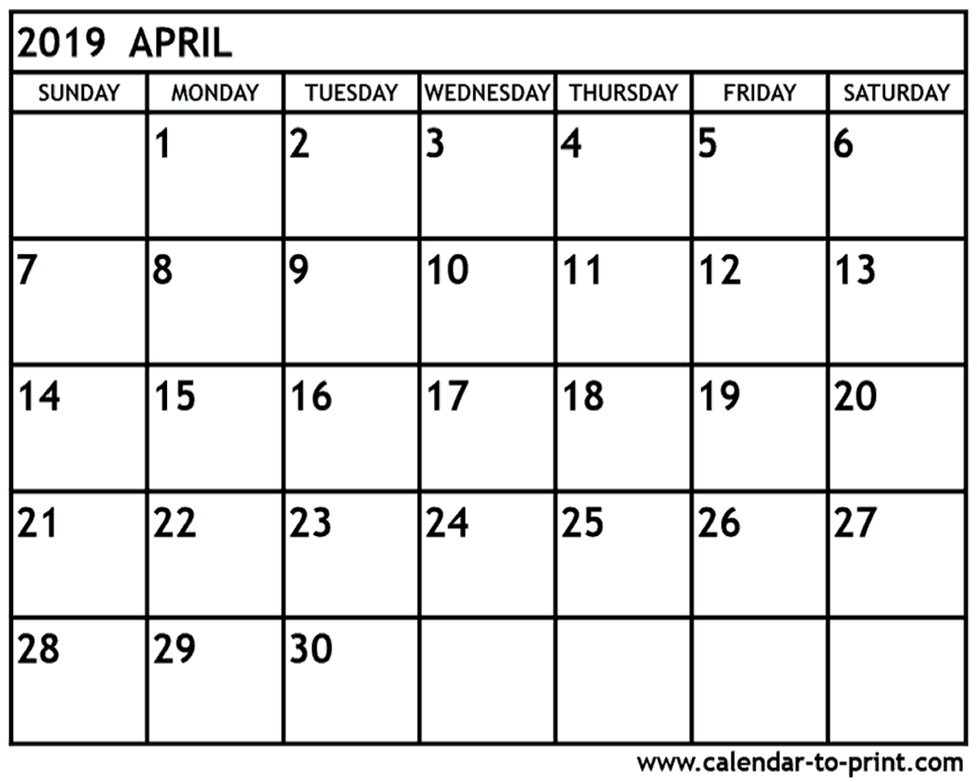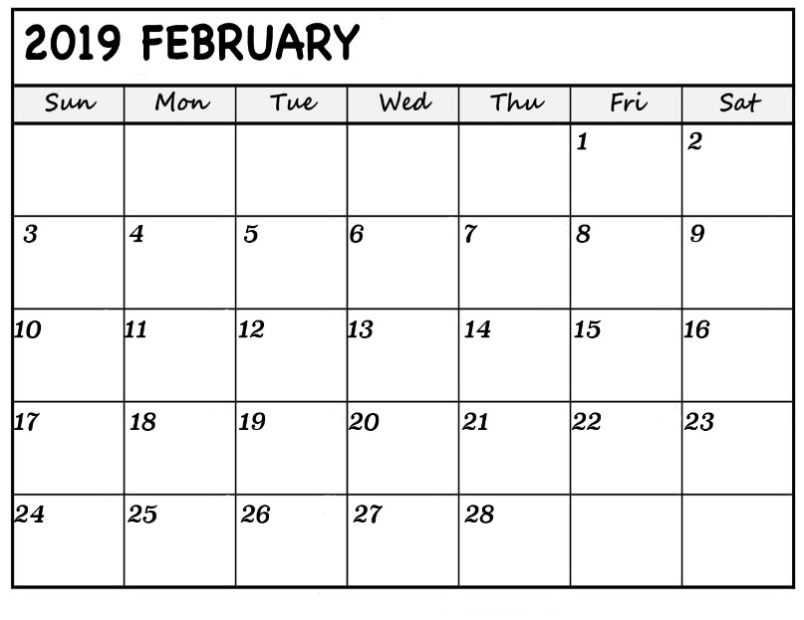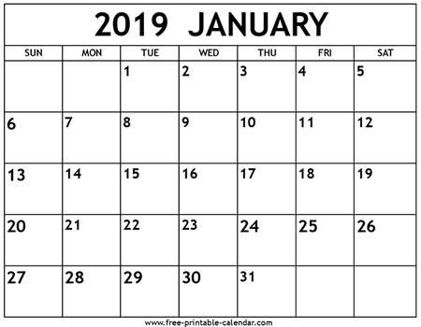

**MOVE IN**

**NtN**

**NtN**

**NtN**